# SharePoint 2013 Demo – Implementing a Custom Brand

## Estimated time to complete this demo

15 minutes

## Objectives

Demonstration of following capabilities in SharePoint 2013

* Implement a custom brand using the Design Manager

## Computers in this demo setup

This demo uses virtual machines as described in the following table. Before you begin the demo, you must start the virtual machines and then log on to the computers.

|  |  |
| --- | --- |
| **Virtual Machine** | **Role** |
| {Supplied by Instructor} | Domain Controller |
| {Supplied by Instructor} | Actual SharePoint environment with Office client and other required software. |

All user accounts in this lab use the password {Supplied by Instructor}.

## Setup Script

This demo assumes you have a Web application created at <http://intranet.contoso.com>. If you do not already have that, create that now.

In the files provided with the demo, run the batch file called **SetupModule.bat** by double clicking it. This file will execute a PowerShell script that will create two new site collections at <http://intranet.contoso.com> and <http://intranet.contoso.com/sites/wcm>.

|  |
| --- |
| Description: C:\Users\vesaj\Pictures\DVD_ART36\Artwork_Imagery\Icons - Illustrations\_ SUPER VISTA STYLE\yield sign red white exclamation point.png **Important** |
| *It is important you run this batch file to create the site collection before working through any of the exercises as the exercises contain instructions for working with this specific site collection at the specific URL created by the script.* |

The script will first check to see if there is already a site collection at the specified address. If there is it will delete the site collection before creating it. Therefore if you run into problems with the demo, feel free to rerun the batch file to reset the environment and restart the exercise.

# Implement a Custom Brand with the Design Manager

In this demo you will implement a custom brand in a SharePoint 2013 Publishing site with the new Design Manager.

## Step 1 - Upload Design Assets

In this task you will upload the raw non-SharePoint design assets to the SharePoint site.

* Begin this task logged on to **SP as CORP\Administrator**.

1. Open Internet Explorer and navigate to <http://intranet.contoso.com/sites/wcm>.
2. Using the gear icon in the top-right corner, go to the **Site Settings** page.
3. Under the **Look and Feel** grouping, select the **Design Manager** link.
4. The Design Manager is a wizard-based experience. Not all steps are covered in this exercise. Jump to step 3, **Upload Design Files**, by clicking the link on the left-hand navigation.
5. Files can be manually uploaded or copied using a mapped folder. Before doing this, simply the demo experience by turning off content approval, check in/out requirements and versioning on the Master Page Gallery:
   * In a new instance or tab of Internet Explorer, navigate to <http://intranet.contoso.com/sites/wcm>.
   * Using the gear icon in the top-right corner, go to the **Site Settings** page.
   * Under the **Web Designer Galleries** grouping, select the **Master Pages and Page Layouts** link.
   * Within the **Master Page Gallery**, use the ribbon to select the **Library** tab and click the **Library Settings** button.
   * On the library settings page select **Versioning Settings** from the **General Settings** column.
   * Change the following settings and click **OK**:
     1. **Content Approval:** No
     2. **Document Version History:** No Versioning
     3. **Require Checkout:** No
6. Map the Master Page Gallery location as a network drive from step 3 in the Design Manager:
   * Copy the URL listed in step 3 (<http://intranet.contoso.com/sites/wcm/_catalogs/masterpage>) to the clipboard.
   * Open **Windows Explorer** (Start 🡪 All Programs 🡪 Accessories 🡪 Windows Explorer).
   * Click **Computer** in the left-hand panel and then click the **Map Network Drive** label:

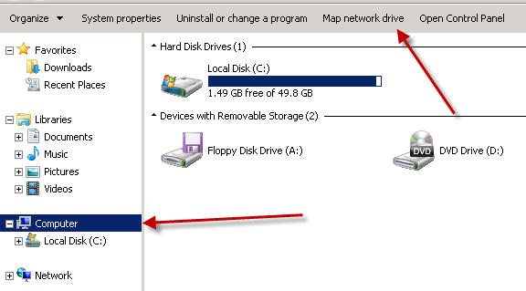

* + In the **Map Network Drive** dialog, click the link **Connect to a Web site that you can use to store your documents and pictures**.
  + In the **Add Network Location** dialog, click **Next**.
  + Click **Choose a custom network location** and click **Next**.
  + Paste the URL of the **Master Page Gallery** and click **Next**. You may be prompted to login to confirm you can access the folder:

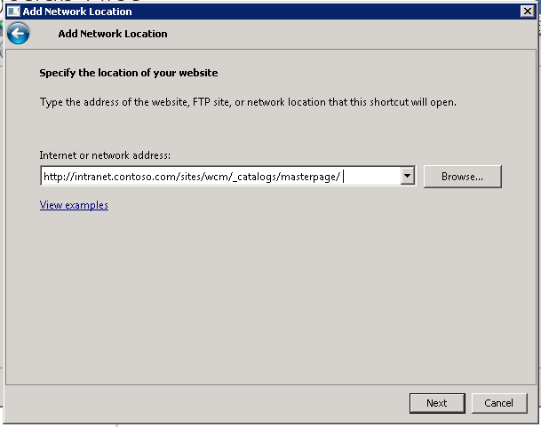

* + When prompted, accept the default name of the location and click **Next** & finally **Finish** to complete the wizard.

1. With a mapped folder created for the Master Page Gallery, copy all the contents from the **DesignManager** folder included with the student files in this demo into the Master Page Gallery.

## Step 2 - Convert the HTML Master Page to a SharePoint Master Page

In this task you will convert one of the files you uploaded in the previous step to a SharePoint master page.

* Begin this task logged on to **SP as CORP\Administrator**.

1. In the **Design Manager**, click on step 4: **Edit Master Pages**.
2. The **Design Manager: Edit Master Pages** page will show all master pages in the Master Page Gallery. You need to convert your HTML file that was previously uploaded to a SharePoint master page. **Click the Convert an existing HTML master page** link.
3. Select the **ContosoMasterDesign.html** file and click **Insert**. Make sure you select the row and don’t click on the actual file link as clicking the link will take you to that file.
4. Accept and/or click through any a prompts you receive and refresh the page until you see the **ContosoMasterDesign** show up on the page with a status of **Conversion successful**.

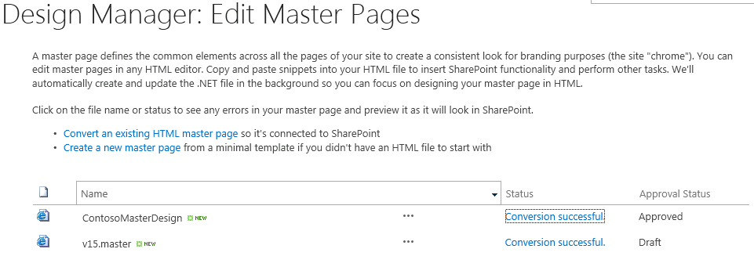

1. Click the **Conversion successful** link for the **ContosoMasterDesign** to open the preview page.

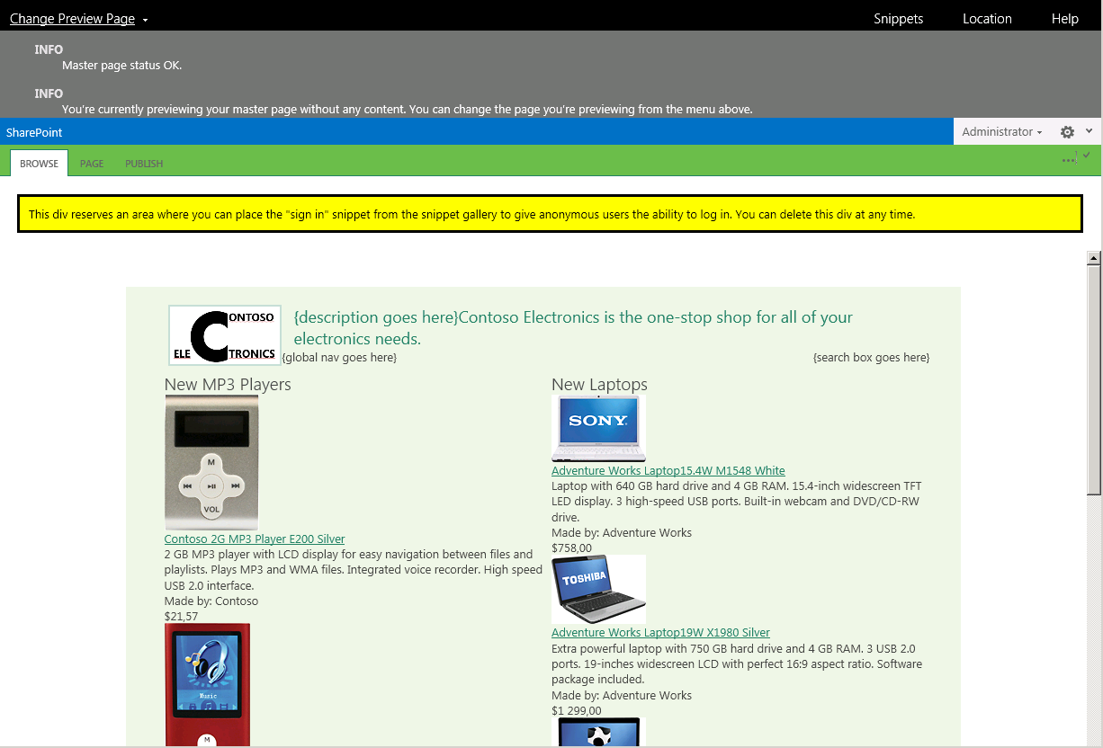

## Step 3 - Customize and Preview the SharePoint Master Page in Notepad

In this task you will customize and preview the changes to your master page in a tool that knows nothing about SharePoint: notepad.

* Begin this task logged on to **SP as CORP\Administrator**.

1. Open **Notepad** (**Start 🡪 All Programs 🡪 Accessories 🡪 Notepad**) and open the **ContosoMasterPage.html** file from the mapped network drive. Ensure you don’t open the \*.master version of this file… only the \*.html version.
2. Jump to line **137** (using the **CTRL+G** shortcut) and add the following code and save your changes:

<h1>Hello World</h1>

1. Go back to the browser that has the preview open and refresh the page to see the changes immediately take effect:

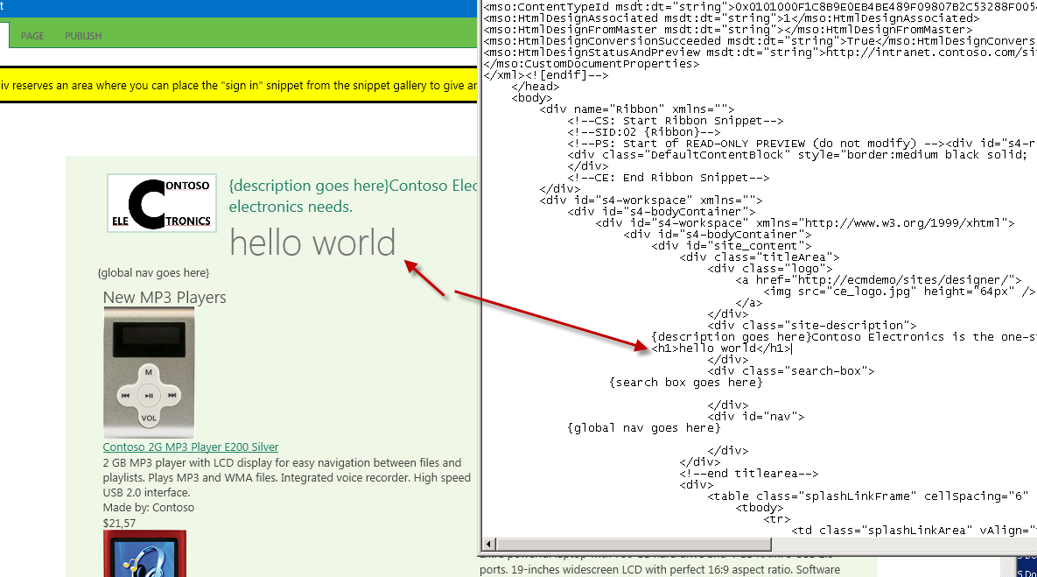

1. That simple change was just to show how the preview experience works. Remove the line you just added and save the page.
2. Add in global navigation for the site using the Snippet Gallery:
   * In the master page preview, click the **Snippets** link in the top-right of the page to launch the Snippet Gallery.
   * In the **Snippet Gallery**, select the **Top Navigation** button from the **Design** tab in the ribbon and select the **0 Flyouts, start from root node** option:

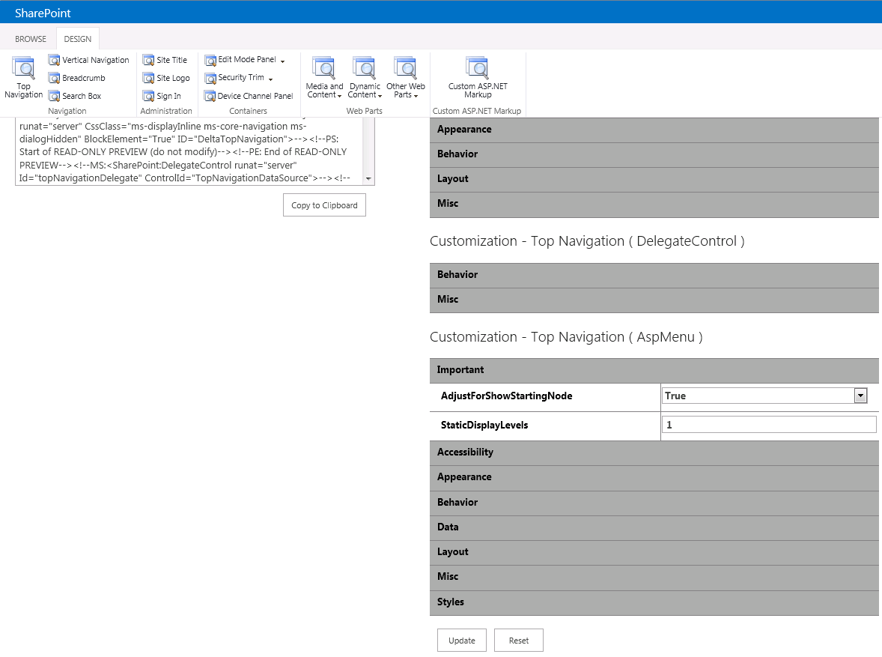

* + Click the **Copy to Clipboard** button under the **HTML Snippet** to copy the HTML generated by the Snippet Gallery.
  + Go back to Notepad and replace the following text with the HTML you copied to the clipboard and save your changes:

{global nav goes here}

* + Go back to the master page preview and refresh the page. You should now see the live navigation being added to the page:

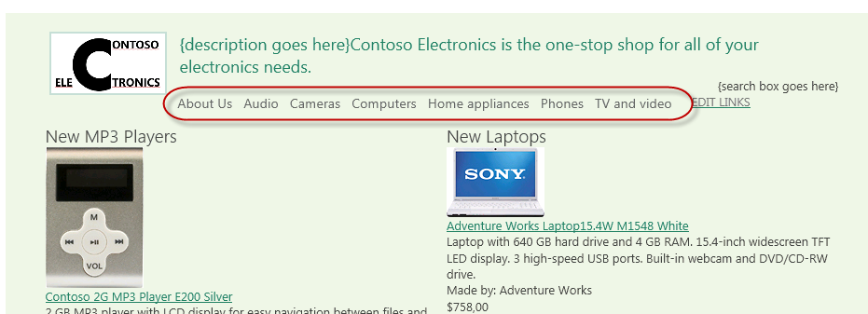

1. Add the search box to the master page.
   * Jump back to the **Snippet Gallery**.
   * Click the **Search Box** button in the Design tab of the ribbon.
   * Click the **Copy to Clipboard** button under the **HTML Snippet** to copy the HTML generated by the Snippet Gallery.
   * Go back to Notepad and replace the following text with the HTML you copied to the clipboard and save your changes:

{search box goes here}

1. Go back to the master page preview and refresh the page. You should now see the live search box being added to the page:

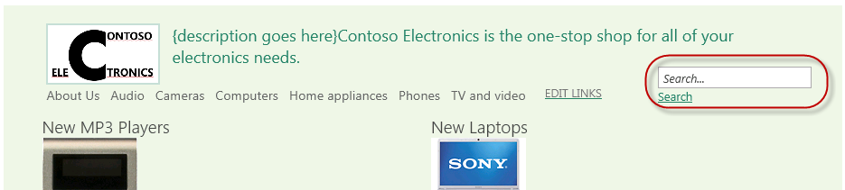

1. Lastly, move the ContentPlaceholderMain control into the area where the rendered content should appear.
   * In Notepad, find the following HTML comment in the master page:

<!--end title area-->

* + Immediately following that title you will see a **<DIV>** followed by a **<TABLE>**. The **<TABLE>** contains the static content used in the designer generated master page. Delete this entire table (it starts around line 165 and goes to around line 315).
  + Jump to the bottom of the master page source. You should a block of HTML that starts with the following markup:

<div name="ContentPlaceHolderMain">

* + Select the entire **<DIV>** and its contents and paste it where the **<TABLE>** was that you just removed.
  + Finally, look for HTML within the <DIV> you just moved that starts with this:

<div class="DefaultContentBlock" style="border:medium black solid; background:yellow; color:black; margin:20px; padding:10px;">

This div, which you should delete, represents the content area that your Page Layouts and pages will fill. Design your Master Page around this content placeholder.

</div>

* + Delete the markup listed above. This was added by SharePoint to highlight where your dynamic content should appear.
  + Save your changes.

1. Go back to the master page preview and refresh the page. You should no longer see the static content:



## Step 4 - Set the Publishing Site to Use the New Master Page

In this task you will configure the Publishing site to use the new master page you have created.

* Begin this task logged on to **SP as CORP\Administrator**.

1. Open Internet Explorer and navigate to the Publishing site at <http://intranet.contoso.com/sites/wcm>.
2. Use the gear icon in the top-right corner of the page to jump to the **Site Settings** page.
3. Under the **Look and Feel** grouping, select **Master Page**.
4. Change the **Site Master Page** to **ContosoMasterDesign** and click **OK**.
5. Go back to the homepage of the site to see how your master page is now being used as the site master page. You can also click on the links in the navigation to view how the rollup pages appear.

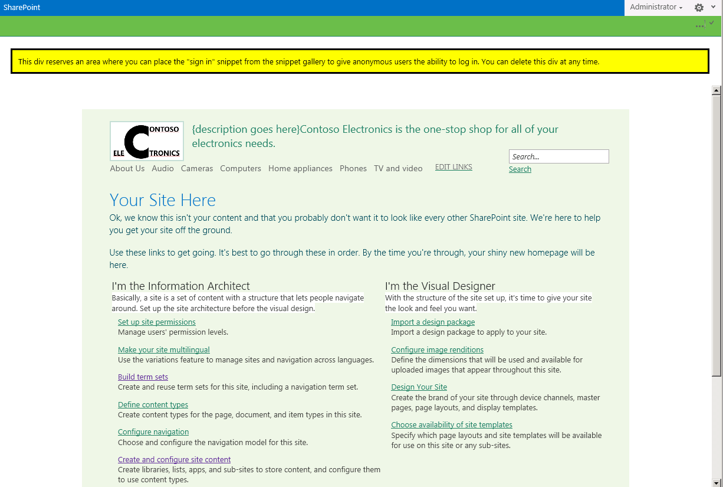

* This is the end of the demo